CHURNGUARD AI

Customer Churn Prediction & Retention Intelligence System

Project Report

Program: MainCrafts Technology — 2-Day Skill Certification
Domain: Artificial Intelligence & Machine Learning
Candidate: SANDHIYA S
Primary Language: Python (Google Colab / Jupyter)
Dataset: IBM Telco Customer Churn (7,043 records, 21 features)

Problem Statement
Businesses lose customers for many different reasons, and companies often discover a customer is leaving only after the customer has already decided to leave. This project builds a machine-learning system that analyzes historical customer data and predicts, in advance, whether a customer is likely to churn — producing an output such as Customer Churn Risk: HIGH or Customer Churn Risk: LOW.

Objective
Build CHURNGUARD AI, an end-to-end machine-learning classification workflow that analyzes customer data, identifies important churn patterns, trains and compares at least two classification models, evaluates the selected model, predicts churn for new customers, identifies the features driving those predictions, and turns the result into a practical business recommendation. The workflow follows: Raw Data → Data Understanding → Cleaning → Feature Preparation → Model Training → Evaluation → Prediction → Business Insight.

Dataset Description
The IBM Telco Customer Churn dataset was used, containing 7,043 customer records and 21 columns, with no missing values or duplicate rows reported by direct inspection. It includes:
- Demographic information: gender, SeniorCitizen, Partner, Dependents
- Account information: tenure, Contract, PaperlessBilling, PaymentMethod, MonthlyCharges, TotalCharges
- Services subscribed: PhoneService, MultipleLines, InternetService, OnlineSecurity, OnlineBackup, DeviceProtection, TechSupport, StreamingTV, StreamingMovies
- Target variable: Churn (Yes / No)

Q1. What is customer churn?
Customer churn is when a customer stops using a company's product or service and leaves for good.
Q2. Why predict churn?
(1) Retaining an existing customer is cheaper than acquiring a new one; (2) it lets retention budgets be targeted at customers actually at risk; (3) it protects recurring revenue and lets the business plan ahead of losses.
Q3. Target variable:
The Churn column (Yes/No).
Q4. Classification or regression?
Classification — the target is a discrete category, not a continuous number.
Q5. What would a false negative mean?
A false negative is a churning customer the model misses. This is the costly error, since that customer is lost with no chance for a retention offer — more costly than a false positive, which only triggers an unnecessary offer to a loyal customer.

Technologies Used
- Python — core language
- Pandas / NumPy — data loading, cleaning and manipulation
- Matplotlib / Seaborn — exploratory data visualization
- Scikit-learn — preprocessing (OneHotEncoder), Logistic Regression, Random Forest, evaluation metrics
- Joblib — saving the trained model
- Google Colab — recommended execution environment

Methodology

Data Preprocessing
The TotalCharges column was loaded as text and contained 11 blank values, which all belonged to customers with tenure = 0 (brand-new customers not yet billed). These were filled with 0 rather than dropped, since dropping would discard real customer records for a value that is genuinely zero. The
non-predictive identifier customerID was removed. Categorical columns were one-hot encoded inside a scikit-learn Pipeline, and the data was split 80/20 into train/test sets using stratified sampling on the target, so both sets preserve the true churn rate.

Exploratory Analysis — Key Findings
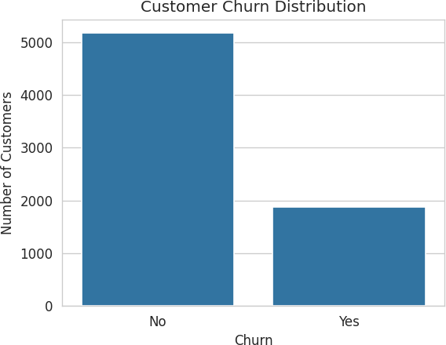

Figure 1. Churn distribution — about 26.5% of customers churned.
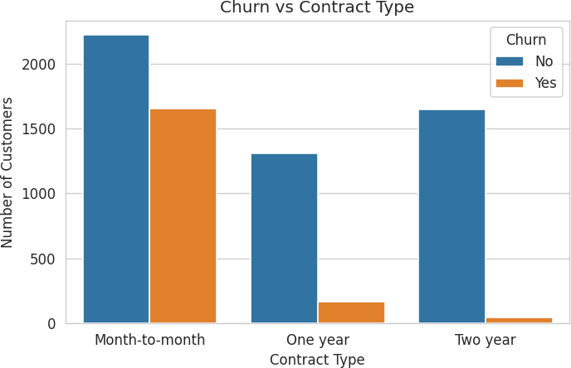

Figure 2. Month-to-month customers churn far more than one/two-year contract customers.

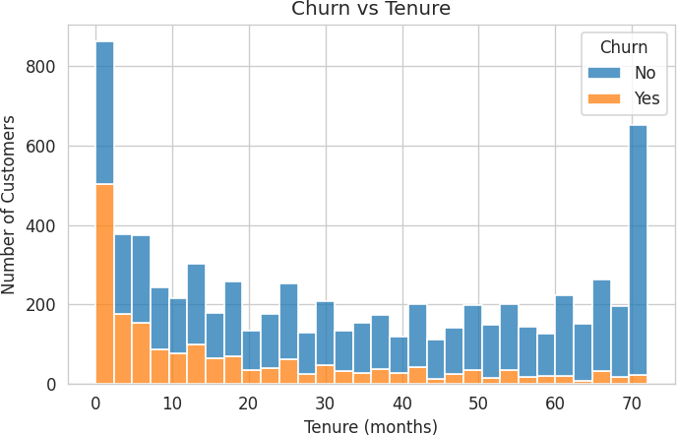

Figure 3. Churn is concentrated in the first ~10 months of tenure.
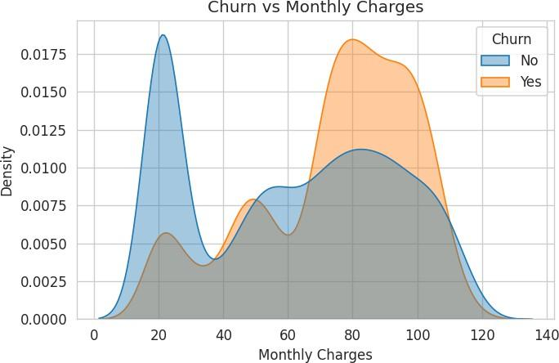

Figure 4. Churners cluster at higher monthly charges (~$70-$100).

Models Tested and Evaluation Results
Two classification models were trained and compared: Logistic Regression and Random Forest (200 trees), both inside a preprocessing pipeline.

Model | Accuracy | Precision | Recall | F1 Score
Logistic Regression | 0.804 | 0.653 | 0.559 | 0.602
Random Forest (default) | 0.793 | 0.642 | 0.489 | 0.551

Which metric matters most, and why? Recall on the churn class matters most here, not raw accuracy. As established above, a false negative (a missed churner) is the expensive error, while a false positive only triggers a comparatively cheap retention offer. Because the dataset is imbalanced (~73.5% stay), accuracy alone can look good while still missing many churners — so the model with the highest accuracy was not automatically selected; the model with the better recall / F1 balance was chosen instead.
Selected model: Logistic Regression — it produced a higher churn-recall than the default Random Forest at only a modest cost in precision.

Confusion Matrix (Selected Model)
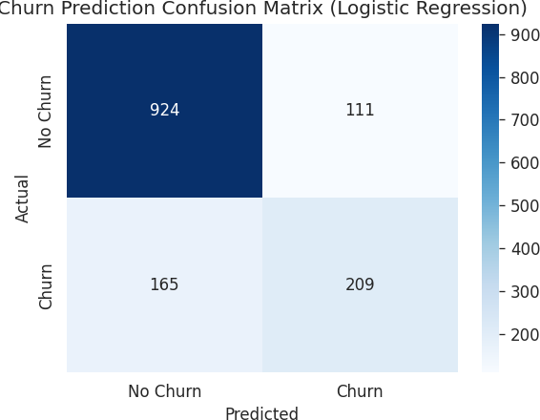

Figure 5. Confusion matrix — 924 true negatives, 111 false positives, 165 false negatives, 209 true positives.

False Negative (predicted stay, actually churned) is the more costly error for a company trying to retain customers, since it means a real churn event goes completely undetected with no chance to intervene.

Model Improvement (Day 2, Challenge A)
The Random Forest model was retrained with class_weight="balanced" and a tuned depth, to counter the class imbalance identified in the EDA.

Random Forest | F1 Score | Recall
Before improvement | 0.551 | 0.489
After improvement (balanced + tuned) | 0.634 | 0.789

What changed? class_weight balancing plus a shallower, tuned tree. Why? Class imbalance suppresses recall on the minority churn class, which Section 6 established as the metric that matters most for this business problem — the change raised recall substantially, at the cost of some precision.

Risk Output (Day 2, Challenge B)
Churn probabilities were converted into three risk tiers: HIGH (probability ≥ 0.70), MEDIUM (0.40–0.69), and LOW (below 0.40). On the test set this produced 95 HIGH-risk, 344 MEDIUM-risk, and 970 LOW-risk customers. These thresholds are a starting judgment call for this exercise, not a universally correct rule — a live deployment would tune them against the real cost of a false negative versus a false positive for the business.

Final Model and Sample Prediction
The trained Logistic Regression pipeline was wrapped in a predict_customer() function and saved to disk with joblib. Example output for a new customer:

Field | Value

Contract | Month-to-month
Tenure | 5 months
Monthly Charges | $79.50
Internet Service | Fiber optic
Predicted Churn | YES
Churn Probability | 67.3%
Risk Level | HIGH

Business Insights
- Month-to-month contracts churn far more than one-year or two-year contracts — a locked-in contract reduces churn.
- Churn is concentrated in a customer's first ~10 months — new customers are the highest-risk group.
- Higher monthly charges (roughly $70–$100) correlate with higher churn — price sensitivity plays a role.

Business Recommendation
Prioritize retention offers — contract-upgrade incentives, first-year loyalty discounts, and service reviews for high-monthly-charge accounts — at new, month-to-month customers, since this segment is most associated with churn in the data.

Limitations
- A model prediction is a probability based on historical patterns, not a guarantee that a specific customer will churn.
- The model was trained on one historical snapshot and may not generalize to a different customer base without retraining.
- The HIGH/MEDIUM/LOW risk thresholds are a starting judgment call and were not tuned against real retention-campaign costs.

Future Improvements
- Tune the risk thresholds against the actual cost of a retention offer versus the cost of a lost customer.
- Add engineered features (e.g. services-per-customer count, average charge per tenure month).
- Retrain periodically on fresh data to keep the model aligned with current customer behavior.
- Extend the optional Streamlit interface into a full internal tool for the retention team.

